Wenhao Cao

EK131

Final report

1st May 1, 2022

Introduction of report

The undeniable fact is the major purpose of the class, EK131, is flexibly combing every techniques and methods we have learned from each class, including model measurement and drawing, construction and print 3D work, electrical knowledge with soldering and insulating skills as well as circuit simulation with coding. As the result, the final project is to create the temperature monitor in the ABS enclosure. This report will demonstrate the specific process of assembly, including the list of components used, code accomplish, challenges existed and the summary of the report.

The motivation of the project is the basic understanding of the method to connect the circuit and the code to activate each component. Only with the practical exercise we could transfer the knowledge to the personal skill. With the further study, I tend to adept advanced knowledge to influence the society.

Design Alternatives Considered

1. The list of components
2. enclosure(with lids)
3. mounting plate
4. 9V battery(with battery holder)
5. TMP36(temperature monitor)
6. LEDs(Red and green)
7. resistor(470 ohm and 1k ohm)
8. buzzer
9. 2-way switch
10. Arduino Uno3
11. Alphanumeric I2C LCD(16\*2 characters)
12. AWC 22 wires
13. jumper wires
14. Purpose of using Arduino board

The Arduino board is the replacement of breadboard and fulfill the code. With the Arduino, it has adjustable voltage, flexible use of interface and code test.

1. Wire diagram

Blue circle means soldering&insulator by hear shrink tubing;

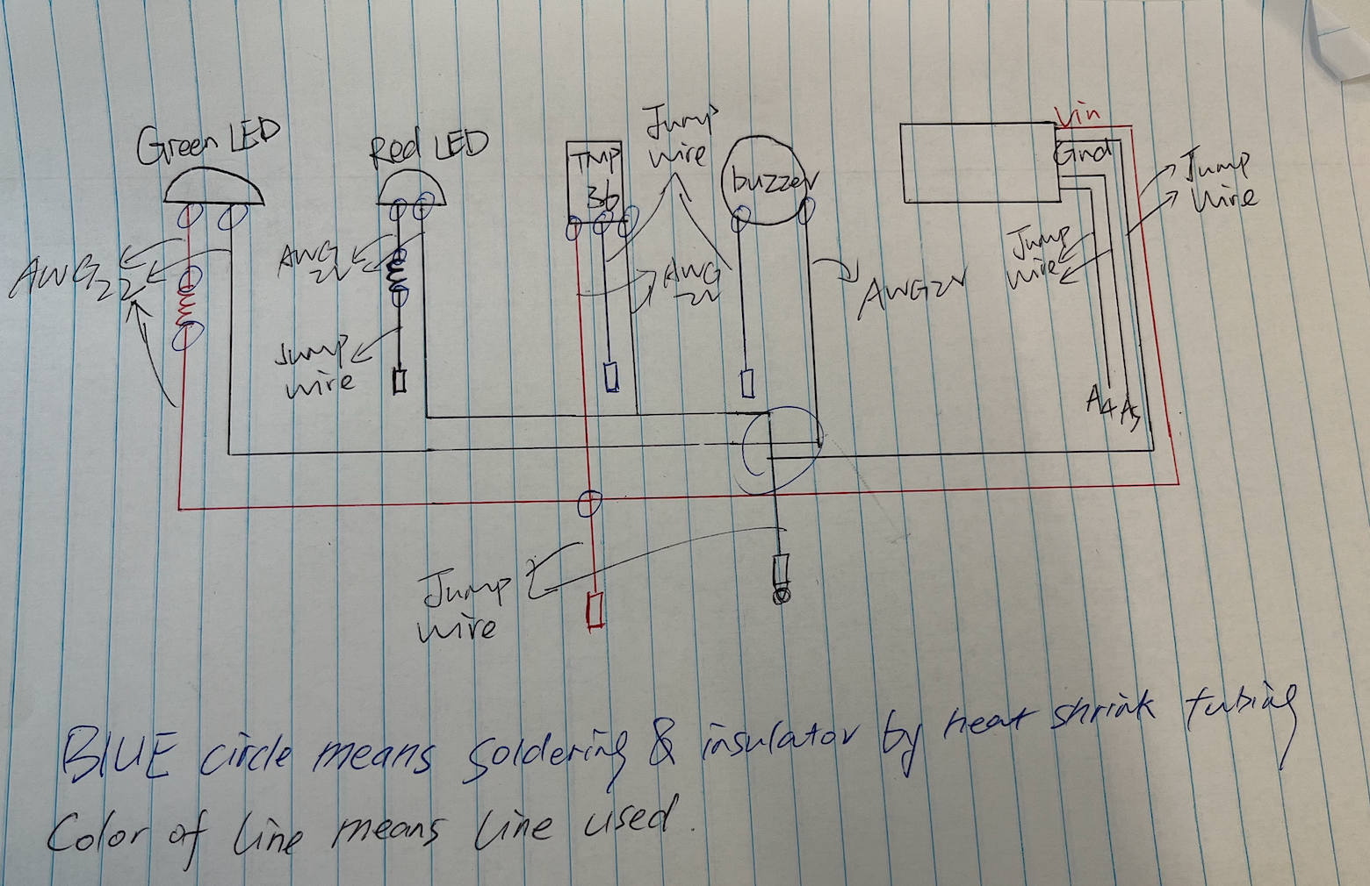color of wires mean the color used;

IV.The choose of power supply is 9V battery due to the voltage is over 5V that satisfy the minimum requirement of code and it’s portable.

V.The operating voltage is 5V, according to the resistance from table AWG, the maximum current should be 7A

VI.Table appendix:

1. precise measurements

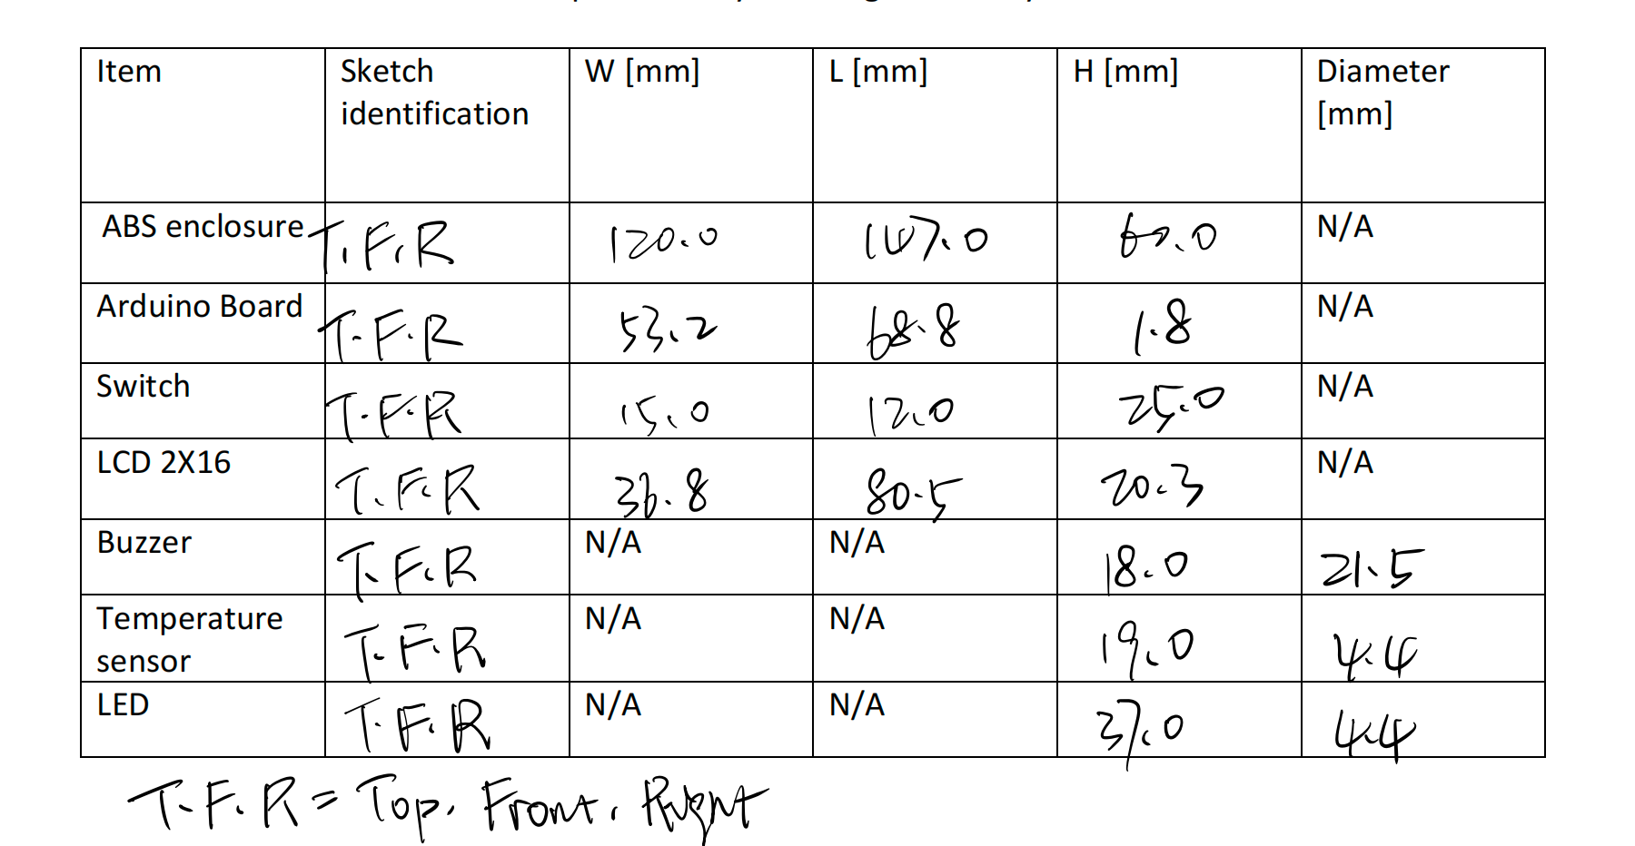

1. free hand sketches and technical drawings(at the end of the report)
2. CAD drawings

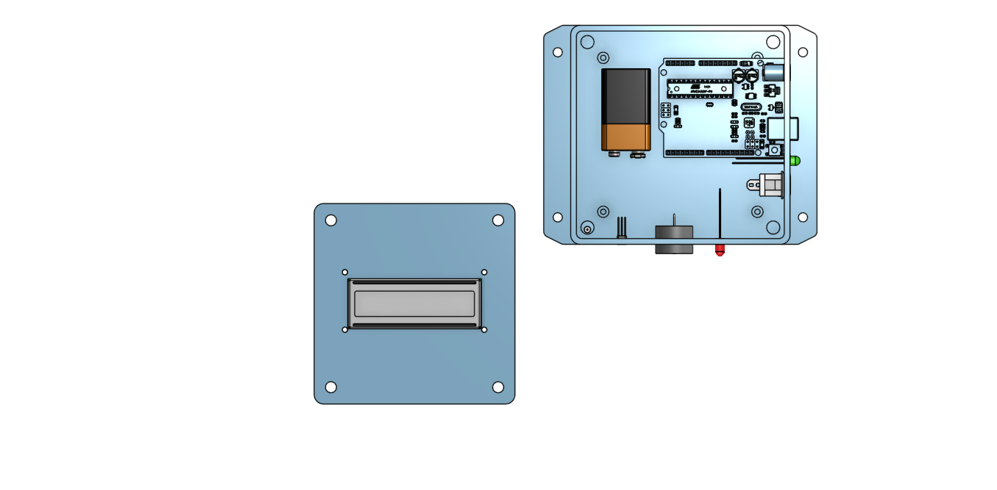

1. placement location of wire

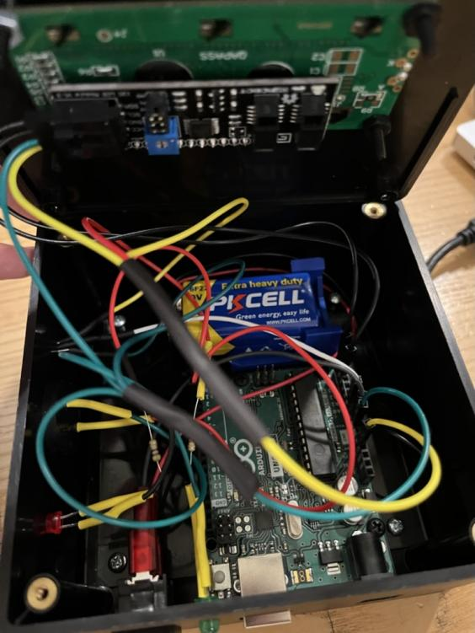

1. code(another file)

Evaluation of Results

The final project, temperature monitor, eventually realize several functions. The major function is showing the surrounding temperature appropriately by turning on and off the switch; With the assistance of code, when the temperature above 75F or below 60F, the red LED will blink with the time of 100ms, and the buzzer send frequency of 1000Hz under the same time. The monitor could be modified by code by change the temperature range, as the result, setting the specific temperature could easily give the reminder for the temperature in order to get fully prepared. However, the monitor is not chargeable, so it should replace the battery regularly; It takes large of area due to the limitation of size.

Summary

All in all, as an engineer, it has the significant meaning to put theory into practice. This is the first time I approach the knowledge of soldering or wire cutting, and the realize of code. As the result, it takes considerable time for to finish the assembly. Many challenges existed during the process, such as the work of preparation. To be honest, I failed the work three times due to the carelessness and my pride. The first time I used BMC instead of TMP36 even though I thought they are the same. Next, I mis-solder the positive and negative of TMP36, these mistakes all cause the temperature showed on the screen is over 400F. At that time, I breakdown and embarrassing because I tend to believe with extensive knowledge and outstanding ability, I could finish it without any effort. It turns out I am wrong, so I ask for advice from professors humbly, and draw the wire diagram. Then I tried the third time, but the result is more disappointment: the color of wire, I randomly choose like use red wine to connect negative pole of LED, definitely the reading is still high. The forth time eventually be correct.

From such experience, I learned a lot. As an engineer, be humble and be careful. A temperature monitor sells only few dollars on Amazon, but still takes large effort to construct from my hands. Nothing is easy, only with such characteristics I could achieve the further success.